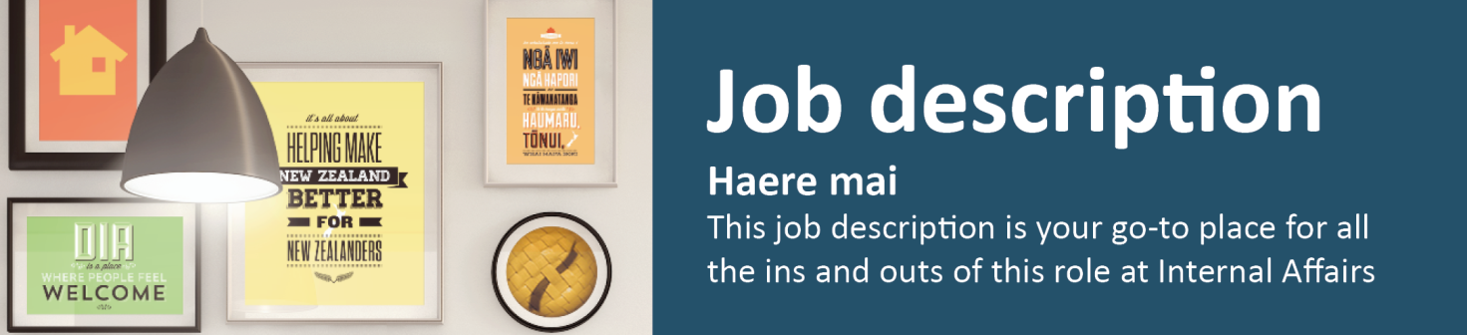
Team Administrator

Kaiwhakarite

Three Waters National Transition Unit/Local Government Branch
The Team Administrator provides professional, effective and efficient administrative support services across the Three Waters National Transition Unit (NTU). This role will add value and improve the workplace experience by providing effective administration, organisational process and system support.
In July 2020, the Government launched the Three Waters Reform Programme – a three-year programme with the ultimate objective of improving the health and wellbeing of New Zealanders.
Currently 67 different councils own and operate most of the drinking water, wastewater and stormwater services across New Zealand. Local government is facing urgent challenges in the provision of these services including: funding infrastructure deficits, complying with safety standards and environmental expectations, building resilience into three waters networks to deal with natural hazards and climate change, and supporting population growth.
The Government has committed to comprehensive, system-wide reform to achieve lasting benefits for our communities and the environment.
The Three Waters National Transition Unit (NTU) is responsible for the establishment of, and transition to, a new service delivery model. Its role is to ensure that, on 1 July 2024, four new water service entities are ready to assume responsibility for three waters-related infrastructure and service delivery.
- Reporting to: Interim reporting line to the Transition Integration Manager
Location: Wellington
- Salary range: Corporate D

What we do matters – our purpose
Our purpose is to serve and connect people, communities and government to build a safe, prosperous and respected nation.
In other words, it’s all about helping to make New Zealand better for New Zealanders.

How we do things around here – our principles
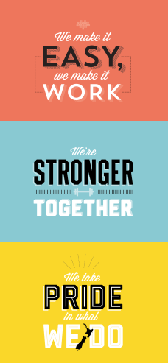 | We make it easy, we make it work  - Customer centred  - Make things even better

We’re stronger together
- Work as a team
- Value each other

We take pride in what we do
- Make a positive difference
- Strive for excellence

Working effectively with Māori
Te Aka Taiwhenua – our Māori Strategic Framework – enables us to work effectively with Māori. Te Aka Taiwhenua is underpinned by our mātāpono – Kotahitanga, Manaakitanga, Whānaungatanga, He Tāngata.
As DIA is an agent of the Crown, Te Tiriti o Waitangi/The Treaty of Waitangi is important to everything we say or do. We recognise it as an enduring document central to New Zealand’s past, present and future. Building and maintaining meaningful relationships is important to work effectively with Māori, stakeholders and other agencies. We accept our privileged role and responsibility of holding and protecting the Treaty of Waitangi / Te Tiriti o Waitangi.

Spirit of service
Ka mahitahi mātou o te ratonga tūmatanui kia hei painga mō ngā tāngata o Aotearoa i āianei, ā, hei ngā rā ki tua hoki. He kawenga tino whaitake tā mātou hei tautoko i te Karauna i runga i āna hononga ki a ngāi Māori i raro i te Tiriti o Waitangi. Ka tautoko mātou i te kāwanatanga manapori. Ka whakakotahingia mātou e te wairua whakarato ki ō mātou hapori, ā, e arahina ana mātou e ngā mātāpono me ngā tikanga matua o te ratonga tūmatanui i roto i ā mātou mahi.
In the public service we work collectively to make a meaningful difference for New Zealanders now and in the future. We have an important role in supporting the Crown in its relationships with Māori under the Treaty of Waitangi. We support democratic government. We are unified by a spirit of service to our communities and guided by the core principles and values of the public service in our work.

What you will do to contribute | As a result we will see
Business Support  - Provide support and assistance to managers and team members as required  - Work with other support personnel to provide administrative and organisational support to the wider NTU, as required  - Provide additional and back-up support to the Personal Assistant to the Director Transition  - Effectively deliver allocated business support  - Contribute to the timely delivery of high quality Ministerial correspondence and support  - Manage scheduling of meetings and coordinate and support team meetings as required, including tracking and managing actions, drafting and disseminating meeting minutes  - Provide meeting support for NTU staff including room bookings, catering, meeting facilities and coordination of attendees  - Manage the flow of all manager correspondence as appropriate  - Ensure the Ministerial database is up-to-date and maintained  - Assist staff to ensure that documentation loaded into CabNET is accurate and complete  - Support staff with event management arrangements as required | - Managers and team members’ needs are well anticipated and are supported to focus on their core roles  - Staff are kept informed and connected  - NTU meets its external and internal reporting requirements  - Meeting participants receive agendas, minutes and action points in advance of the meeting to sufficiently prepare  - Smooth flows of correspondence with timely responses to emails and other communications  - Requests are dealt with in an efficient and effective manner to achieve outcomes  - The Ministerial database is kept accurate and up to date
Team Administration  - Monitor team administrative priorities, workload and travel/accommodation requirements  - Order non-standard stationery for all NTU staff as required and sort and distribute mail  - Assist in producing high quality documents including formatting, printing, collating, photocopying and distribution  - Manage the drafting and preparation of letters, presentations, reports, briefings and minutes as required by the manager(s) or team  - Monitor the information management requirements for the team  - Manage and maintain filing systems, both electronic and paper-based  - Assist with staff onboarding and induction, including scheduling training, facilitating desk and ICT set-up and authorisations as required  - Assist with team wide administration, including travel bookings, meetings etc.  - Provide cover for the Personal Assistant as required | - Team members are communicated with effectively  - Effective, timely and proactive administrative support is provided to the NTU  - Papers meet Ministerial timeliness standards  - The office is stocked with adequate supplies and all equipment is functional  - Proactive communication re: the progress on tasks and updates is provided when there are delays  - All administration tasks are completed accurately and to the agreed standards
Financial Administration  - Raise purchase order requests, and receipt when goods have been received  - Process all invoices by checking invoices, coding and arranging for appropriate sign-off  - Forward invoices to Finance within agreed timeframes  - Prepare financial returns and reports as required  - Reconcile P-Card transactions  - Complete the monthly accruals | - All NTU goods and services purchases complies with relevant DIA policies and procedures  - Payments are processed according to departmental processes, delegations and policies  - Invoices are received by Finance within agreed timeframes and suppliers are paid on time  - Managers are confident that all finance administration tasks are completed to agreed standards
Information Technology  - Action (and support others to action as needed) Service Desk requests for ICT related issues, repairs and supplies in the office  - Coordinate the setup of ICT resources as required by the team and Service Desk  - Monitor team requirements for all office ICT equipment including phones, laptops, data projectors and Wi-Fi etc. | - Information technologies support NTU staff to work efficiently and effectively  - Office ICT equipment is tracked, accounted for and used appropriately
Documentation and Collaboration Tools  - Provide word processing and document preparation support, including formatting documents, presentations and spreadsheets e.g. Cabinet Papers, briefings and Ministerial correspondence  - Provide information management coordination support, including awarding access, ensuring MS Teams and Cohesion processes are working effectively  - Support the timely use of Cohesion and other Department filing systems by NTU staff and educate users as required | - Documents, presentations and spreadsheets are prepared and filed to agreed standards in an accurate and timely manner  - Cohesion and MS Teams systems and processes are working effectively
Health and safety (for self)  - Work safely and take responsibility for keeping self and colleagues free from harm  - Report all incidents and hazards promptly  - Know what to do in the event of an emergency  - Cooperate in implementing return to work plans | - A safe and healthy workplace for all people using our sites as a place of work.  - Health and safety guidelines are followed

 |  | Advise | Collaborate with | Influence | Inform | Manage/  lead | Deliver to
Who you will work with to get the job done
Internal | Senior leaders and managers across Three Waters
 | NTU team members, including other support staff
 | Other Local Government Branch staff
 | Relevant DIA Staff
External | Minister’s Offices
 | Other government agencies

Your delegations
Human Resources and financial delegations | Level Z
Direct reports | 0

Your success profile for this role | What you will bring specifically
At DIA, we have a Capability Framework to help guide our people towards the behaviours and skills needed to be successful. The core success profile for this role is Valued Contributor.  Keys to Success:  - Customer Focus  - Continuous improvement  - Teamwork and peer relationships  - Action oriented  - Self-development and learning  - Functional and technical skills | Experience:  - Experience working in a fast paced, high demand Business Support Administration role with minimal supervision  - Proven experience managing high volumes of work within tight time frames, to required quality standards  - Proven experience providing efficient and effective administration services to a senior manager, preferably in the Public Sector  - Proven experience with electronic document management and tracking systems  - Proficiency in working with financial systems and information  Knowledge:  - Proficiency in spoken and written English  - Basic knowledge of planning and reporting processes  - Proven ability in the use of Microsoft Office including; Outlook, Word, PowerPoint, Visio, Excel and Access  - Proven competence with common ICT applications used in the public service  Skills:  - Displays the personal maturity and integrity to make good judgments about people, events and risks especially when dealing with sensitive issues  - Excellent communication skills, both written and verbal and well-honed use of initiative in a busy office environment  - Strong customer service disposition  - Strong stakeholder relationship management focus and interpersonal skills, with the ability to interact with people at all levels  - Team focused work ethics and the ability to work collaboratively across team boundaries  - Detail focused with the ability to anticipate risks and the consequences of decisions and commitments  - Advanced Microsoft Outlook skills with the ability to effectively manage the inbox and calendar  - Fast and accurate keyboard skills  - Ability to prioritise workloads and negotiate deadlines in the face of competing demands

