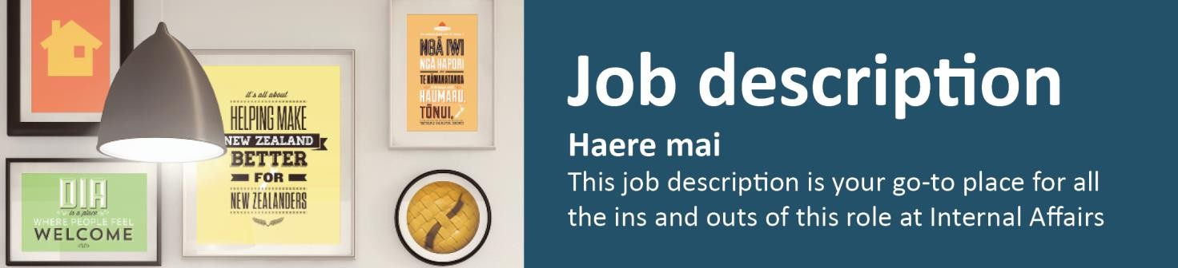

Manager Project Delivery

Business Change, Technology Services & Solutions, Organisational Capability and Services Branch
The Manager Project Delivery roles are accountable for high quality project delivery to their assigned branches within the Department. They lead and manage teams that provide project management and project leadership capabilities that enable the Department to meet its strategic and operational objectives. They work with branch leaders to ensure projects and work requests deliver the intended business outcomes and with other business units across the investment system to drive efficiency, quality, agility and innovation in project delivery.
- Reporting to: Manager Business Change
- Location: Wellington
- Salary range: Information Technology J

What we do matters – our purpose
Our purpose is to serve and connect people, communities and government to build a safe, prosperous and respected nation.
In other words, it’s all about helping to make New Zealand better for New Zealanders.

How we do things around here – our principles
We make it easy, we make it work
- Customer centred
- Make things even better
We’re stronger together
- Work as a team
- Value each other
We take pride in what we do
- Make a positive difference
- Strive for excellence

Working effectively with Māori
Te Aka Taiwhenua – our Māori Strategic Framework – enables us to work effectively with Māori. We accept our privileged role and responsibility of holding and protecting the Treaty of Waitangi / Te Tiriti o Waitangi.

What you will do to contribute | As a result we will see
People Leadership and Management  - Recruit, lead and manage the team in line with HR guidelines and the people leader profile of the DIA capability framework  - Ensure the team are clear on their role, function, goals/outcomes and their contribution to TSS and the Department  - Proactively mentor, coach and support team members to develop skills, adopt new ideas and develop practices  - Enhance the performance culture within the team, setting clear expectations, holding people accountable and actively managing and enabling delivery  - Actively manage the forecast workload and resourcing levels for the team to best match “the right people to the right work at the right time”  - Undertake regular DIA culture and engagement activities with the team. | - Behaviour as a people leader in line with DIA Capability framework  - High performing and high potential staff are effectively recruited, developed, supported and retained.  - Active performance management and development of staff, leading to improved delivery over time  - Effective matching of people to Department demands and needs
Project and work request delivery  - Lead the project management team to deliver successful project and work request outcomes for the assigned branches  - Be the single point of responsibility for project delivery for the assigned branches  - Develop and foster valued ‘trusted advisor’ relationships with senior leaders in the assigned branches, based on a sound understanding of their business needs  - Work with the IT, HR and Finance Business Partners, Service Delivery Managers, EPMO advisors and vendors to deliver successful business and technology outcomes for the assigned branches  - Perform the Senior Supplier role for selected projects/programmes | - Successfully delivered projects that contribute to DIA/branch/group objectives and plans  - Project deliverables meet Departmental project management standards  - The Manager Project Delivery is recognised and sought out by senior leaders as a trusted advisor on project delivery  - A well-developed pipeline of current and future work  - Positive view of TSS project delivery and TSS overall

What you will do to contribute | As a result we will see
Capability Development  - Monitor and improve the quality of project delivery within the assigned branch  - Work with the other Manager Project Delivery roles, the Quality and Assurance Advisor and EPMO to drive improvements in project delivery capability, methods and processes.  - Provide advice to project teams and business owners on best practice and fit for purpose project approaches and methodologies | - Consistent discipline based practice that includes consistent use of tools, frameworks and process that are appropriate for the size of projects the Department undertakes  - Project deliverables meet Departmental project management standards  - Consistent improvement and innovation in project delivery capability that lead to the team being recognised as agile, innovative and responsive
Financial management  - Accountability for financial performance against budget and forecast for the team  - Produce accurate and reliable budgets and forecasts of revenue and expenditure and manage to these  - Actively manage the levels of permanent and contract staff to meet expected demand and maximise value to the Department | - Expenditure is managed within agreed budget and when necessary updates to forecasts are made  - All finance and procurement processes are followed  - The levels of permanent and contract staff are regularly adjusted based on forecast work pipeline and projects have the people they need to deliver on time  - Utilisation levels are tracked and potential recovery issues are identified early and addressed
Health and safety (for self)  - Work safely and take responsibility for keeping self and colleagues free from harm  - Report all incidents and hazards promptly  - Know what to do in the event of an emergency  - Cooperate in implementing return to work plans  Health and safety (for team)  - Inform, train and equip staff to carry out their work safely  - Ensure prompt and accurate reporting and investigation of all workplace incidents and injuries  - Assess all hazards promptly and ensure they are managed | - A safe and healthy workplace for all people using our sites as a place of work.  - All requirements of DIA’s Health and Safety policy and procedures are met.

ise
borate
ence
rm
age/
er to

Who you will work with to get the job done |  | Adv  Colla with  Influ  Info  Man lead  Deliv
Internal | TSS Leadership Team | ✓ | ✓ |  | ✓ |  | ✓
 | Business Change Leadership Team | ✓ | ✓ | ✓ | ✓ |  | ✓
 | Project Delivery team staff | ✓ | ✓ | ✓ | ✓ | ✓
 | TSS managers and staff | ✓ | ✓ | ✓ | ✓ |  | ✓
 | DIA Business group managers | ✓ | ✓ | ✓ | ✓ |  | ✓
 | EPMO |  | ✓ | ✓ | ✓ |  | ✓
External | Government departments and agencies | ✓ | ✓ | ✓ | ✓
 | Key vendors | ✓ | ✓ | ✓ | ✓ | ✓
 | Institutions and bodies with practice expertise |  | ✓

Your delegations as a manager
Human Resources and financial delegations | Level E
Direct reports | 10 - 20

Your success profile for this role | What you will bring specifically
At DIA, we have a Capability Framework to help guide our people towards the behaviours and skills needed to be successful. The core success profile for this role is People Leader.  Keys to Success:  - Setting expectations  - Encouraging innovation  - Building effective teams  - Identifying talent and developing others  - Motivating others to achieve results  - Developing business acumen | Experience:  - Demonstrated competency in project management and in managing the execution of multiple large scale projects critical to the delivery of business strategies and goals  - Demonstrated leadership of multidisciplinary, high-performance work teams/groups  - Significant experience of operating in complex environments with multiple objectives and clients  - Developing a business focused and service orientated culture  Knowledge:  - A strong understanding of the principles and practices applied by project managers  - A sound knowledge of risk management and quality assurance particularly in relation to projects and people  - Financial literacy and ability to interpret financial data  - A broad awareness of a range of technologies and their practical applications in supporting business requirements

Your success profile for this role | What you will bring specifically
Skills:
- Facilitation of collective decision making
- Negotiation, influencing and relationship management skills at a senior level
- Problem solving skills
- An openness to new ideas and activities
- Ability to communicate project management concepts to a broad range of technical and non-technical employees.
Other requirements:
- Tertiary qualification in an appropriate field/or equivalent experience
- Ability to obtain and maintain a confidential security clearance

