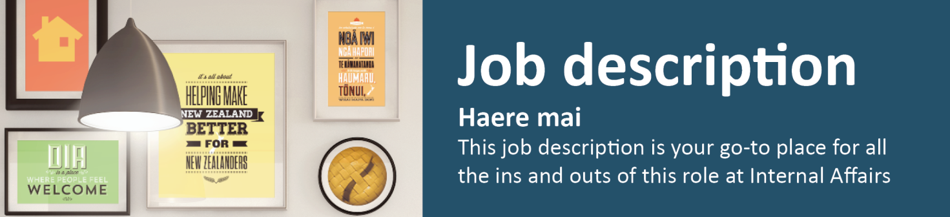
Intern

Accountability Team, Regulatory Services
The purpose of this internship is to provide graduates with the opportunity to gain working experience within the public sector and gain exposure to ‘real work’ related to their qualification.
Specifically, this internship will support the Strategy and Accountability Directorate to manage and respond to Official Information Act requests, and to support internal and external accountability processes for the Regulatory Services Group.
- Reporting to: Manager, Accountability
- Location: Wellington

What we do matters – our purpose
Our purpose is to serve and connect people, communities and government to build a safe, prosperous and respected nation.
In other words, it’s all about helping to make New Zealand better for New Zealanders.

How we do things around here – our principles
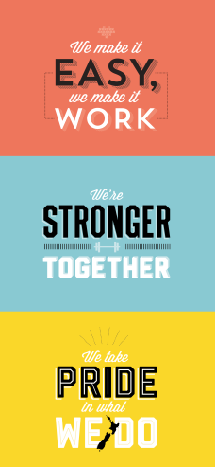 | We make it easy, we make it work  - Customer centred  - Make things even better

We’re stronger together
- Work as a team
- Value each other

We take pride in what we do
- Make a positive difference
- Strive for excellence

Working effectively with Māori
Te Aka Taiwhenua – our Māori Strategic Framework – enables us to work effectively with Māori. We accept our privileged role and responsibility of holding and protecting the Treaty of Waitangi Te Tiriti o Waitangi.

What you will do to contribute | As a result we will see
Continuous Improvement and Best Practice  - Identifies opportunities for continuous improvement within the business group  - Engage with the Intern Programme | - Produces ideas on systems and process improvement  - Successful completion of the DIA Intern Programme
Informing and Relationship Management  - Work collaboratively as part of a team  - Keeping manager’s and business group regularly informed on work progress | - Effective collaboration  - Trusted and respected relationships
Customer Focus  - Understanding the needs or expectations of customers  - Meets customer deadlines and team SLA’s | - Customers feel they are receiving a trusted service
Support to Wider Business Group  - Provide support and assistance to other staff across the business group as required | - Support provided to other business group staff as needed
Health and Safety (for self)  - Work safely and take responsibility for keeping self and colleagues free from harm  - Report all incidents and hazards promptly  - Know what to do in the event of an emergency  - Cooperate in implementing return to work plans | - A safe and healthy workplace for all people using our sites as a place of work.  - Health and safety guidelines are followed

 |  | Advise | Collaborate with | Influence | Inform | Manage/  lead | Deliver to
Who you will work with to get the job done
Internal | Reporting Manager
 | Business Group Leadership Team
 | Business Group Staff
External | Sector stakeholders

Your delegations
Human Resources and financial delegations | Level Z
Direct reports | None

Your success profile for this role | What you will bring specifically
At DIA, we have a Capability Framework to help guide our people towards the behaviours and skills needed to be successful. The core success profile for this role is Valued Contributor.  Keys to Success:  - Customer Focus  - Continuous improvement  - Teamwork and peer relationships  - Action oriented  - Self-development and learning  - Functional and technical skills | Experience:  - Experience in effectively managing a wide range of relationships  - Demonstrated experience meeting timeframes and producing a high quality of work  Knowledge:  - Proficiency in spoken and written English  Skills:  - Excellent communication skills, both written and verbal  - Strong organisational and prioritisation skills and the ability to be proactive and flexible  - Strong stakeholder relationship management focus and interpersonal skills  - Team focused work ethics and the ability to work collaboratively across team boundaries  - Sound computer skills and understanding of Microsoft Office products  Other requirements:  - Working towards a relevant tertiary qualification

